Instructions Handout

In this game you are one of us: An ECE student in the fourth semester at the University of Toronto. In this game you will be exposed to the obstacles faced by an ECE student and you will have to dodge them by jumping or ducking them.

Controls:

  
 = Jump



= Duck



= Restart/Start (Push button 3)

Obstacle Descriptions:

The obstacles used in this project are very specific to the experience of a ECE student in the fourth semester of Winter 2021 and hence we would like to explain the context in which they were used.



This is an equation we came across in ECE 216



This is an audio wave from one of our ECE 216 labs



This is the MATLAB logo symbolizing our ECE 216 labs as it was the interface we were supposed to use throughout the semester.



This obstacle reminds us about the fact that we were not allowed to track back in our first ECE 221 Mid Term Test which led to a very difficult experience for most students in that test.

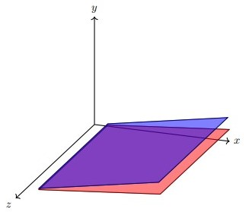

This is an image of the diagram that was in Q7 of ECE 221 Test 1. A lot of students found this question extremely challenging.



This of course is the ModelSim logo which reminds us about the confusing waveforms we leaned about in ECE 241 and in ECE 243.



This is the image of a processor to remind us about the challenges faced while doing Lab 2 in ECE 243.



This is an equation we came across in chapter 7 of ECE 231.



This is the LTspice logo inside a red triangle. This reminds us of the exhausting ECE 231 Labs.



This is a statement from the ECE 231 Mid Term Test results announcement and as you can see from the average, it was not easy.



This image reminds us about Milestone 2 in ECE 297 where we had to set up the graphics of a GIS. This was a very time taking process.



This image reminds us about Oral Presentation 1 in ECE 297.



The algorithm in Milestone 3 of ECE 297 was very challenging and required a lot of thinking.

Lifelines:

We also had our moments when we were relieved of our burden may it be because of the bell curve or some other policy changes. We have not forgotten to give it due credit and recognition in our game!

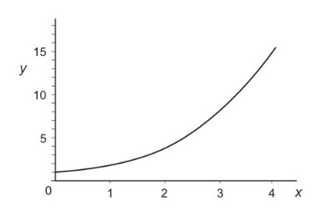

This is an image of a curve which is a lifeline for several students in U of T engineering.



Finally, this is a screenshot from Quercus regarding the new grading scheme for ECE 243 which will hopefully be a lifeline for a lot of students in this course.

Attribution Table

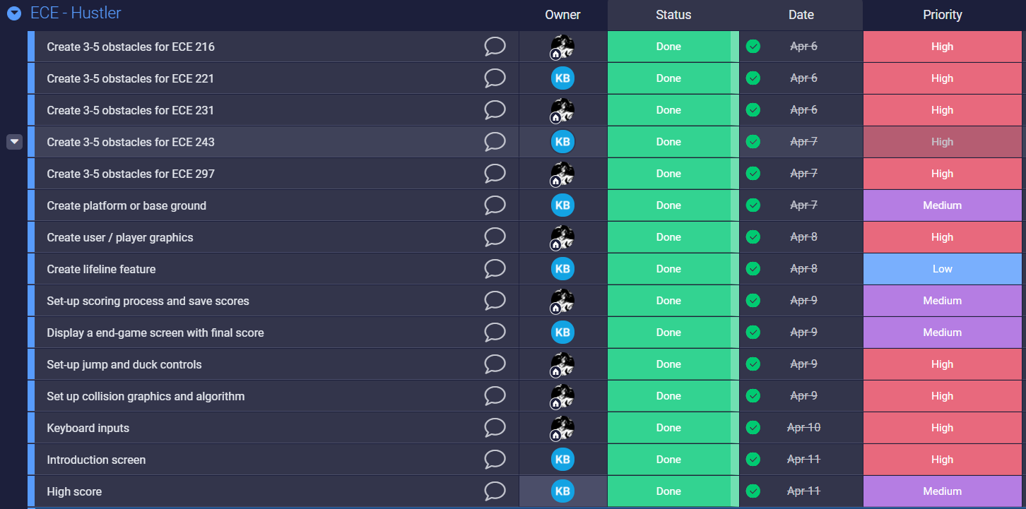

KB: Kshitij Bhardwaj  
Other: Hetav Pandya

**Hope you enjoy our game!**

**- Hetav Pandya and Kshitij Bhardwaj**